Student Name: Xianglong Lin Student Number: 45791439 Team Name: H2OMG
Week: _4_
Title: Ethical Implications in Water Usage Tracking
Description:
In Week 4, our team's attention was drawn to ethical considerations in the design project, particularly concerning the tracking of water usage in households. Building on the research methods established in Week 3, this week we focused on addressing potential user privacy issues that may arise during the collection of water consumption data. We conducted an in-depth analysis of a scenario involving a father who is surprised and frustrated by a high water bill, struggling to identify the cause of the excessive water usage. Despite his efforts to reduce water consumption, he is still unable to pinpoint the problem, and therefore a more efficient solution is needed. This illustrative scenario helped us recognise several key ethical issues:
- Confidentiality: Water usage data should be securely stored and accessible only to the user, preventing unauthorised access and privacy breaches.
- Consent for Monitoring: Users must be informed and fully aware of what data will be collected, how it will be used, and who will have access to it. This requires us to establish clear and transparent communication upfront, covering the purpose of monitoring and ensuring the integrity of voluntary participation.
- Private Spaces Within the Home: Our design must not intrude on areas that users consider private, such as bedrooms or bathrooms, and in any case, it is safest to seek permission. This is an important measure to maintain appropriate boundaries and avoid invading privacy.
Visual Evidence:
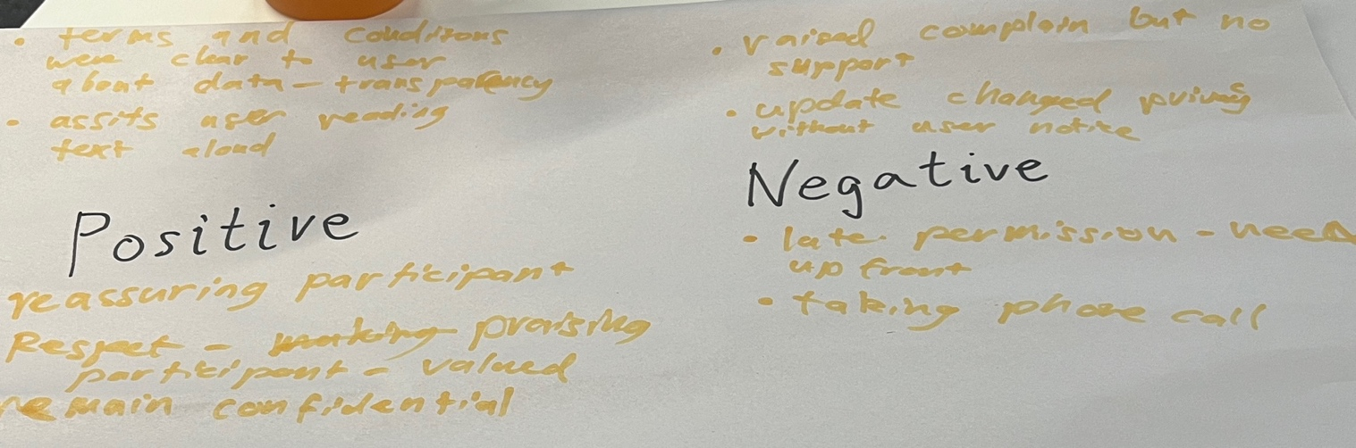
Statement on Learning:
This week's studio on ethical considerations has made me fully aware of the importance and necessity of considering user privacy and consent when designing project solutions. Through the analysis of the specific water usage scenario, I concluded that ethical design is not only about avoiding harm but also about respecting the user's autonomy and personal space. Additionally, I have gained a renewed understanding of the concept of minimising harm in design. Although data is an indispensable part of designing solutions, it is essential to ensure that the user is informed and comfortable with the way data is collected. This principle will undoubtedly be fundamental to the success of our final design in solving the problem while adhering to ethical standards. Overall, careful consideration of ethical issues and the formulation of guidelines will lead our team to create solutions that are both innovative and responsible, truly achieving a user-centred approach!

